**ONLINE JOB PORTAL**

Submitted by

**RAHUL J**

**Reg.No: 20191231506225**

**RAMGANESH P**

**Reg.No: 20191231506226**

A Project report Submitted to

**SRI PARAMAKALYANI COLLEGE**

(Accredited with ’A’ Grade by NAAC(CGPA-2.76))

Affiliated to

**MANONMANIAM SUNDARANAR UNIVERSITY**

In Partial fulfillment of the requirements for the award of the degree of

**BACHELOR OF COMPUTER SCIENCE**

2019-2022



Guided by

**Mr. P. NITHIN, B.Tech., M.E**

BACHELOR OF COMPUTER SCIENCE

SRI PARAMAKALYANI COLLEGE

ALWARKURICHI-627412

**SRI PARAMAKALYANI COLLEGE**

**ALWARKURICHI - 627412**

**CERTIFICATE**

This is to certify that the project work entitled

**“ONLINE JOB PORTAL"**

is a Bonafede work done.

**By**

**RAHUL J - Reg. No: 20191231506225**

**RAMGANESH P - Reg. No: 20191231506226**

In partial fulfillment of the requirement for the award of the degree of Bachelor of Science

in Computer Science of during the

Academic Year 2019 - 2022

**Head of the Department**  **Guide**

**Principal**

Submitted for the university examination held on ..............................

**Internal Examiner** **External Examiner**

**DECLARATION**

We hereby declare that this project work entitled "**ONLINE JOB PORTAL"** is the result of the original work done by us and to the best of any knowledge a similar work done by us ad to the best of any knowledge a similar work is not been submitted earlier for the fulfilment of the requirements of the course of study.

This Project report is submitted of partial fulfilment of the requirement for the award of the degree of Bachelor of Science in Computer Science, Sri Paramakalyani College, Alwarkurichi.

**S. No Name Reg. No Signature**

**1. J. RAHUL 20191231506225**

**2. P.RAMGANESH 20191231506226**

Place:

Date:

**ACKNOWLEDGEMENT**

We tender our most graceful thanks to the great almighty God giving us an opportunity to purse in this esteemed Institution of Sri Paramakalyani College, Alwarkurichi, and he has showered his blessing all throughout our life.

We wish to express our gratitude to the management of the college for giving an opportunity to be a student of this reputed institution. And we express our sincere thanks to Principal **Dr. R. Venkataraman M.Sc., M.Phil. Ph.D**. He has provided a supportive climate, criticism and feedback.

Our heartfelt thanks to **Mr. R. Ranjith., M.C.A., M.Phil., M.E., (CS, SET),** Head of the Department of Computer Science, Sri Paramakalyani College, Alwarkurichi for giving this opportunity to work on this project and supporting us with his valuable suggestions.

We are graceful to thank our Project Guide **Mr. P. NITHIN, B.Tech., M.E**

for supporting us with his valuable suggestions.

Our deep sense of gratitude to all the other faculty members of the Department of Computer Science, Sri Paramakalyani College, Alwarkurichi for their timely help in completing the project work and also in our academic activities.

We also feel happy to thanks out parents for their devotion, love and appreciation complete this project successfully.

**CONTENTS**

|  |  |  |
| --- | --- | --- |
| S.NO | TITLE | PAGE.NO |
| 1  2  3  4  5  7  8  9  10  11  12  13 | Abstract  Introduction  System Analysis  Existing system  Proposed system  System Specification  Hardware Specification  Software Specification  Software Description  System Design  Flow chart Diagram  Data Flow Diagram  Use case Diagram  Module Description  Data Base Design  Input/Output  Sample Code  Future Enhancement  Conclusion  Bibliography | 6  7  8  9-18  19-23    24-25  26-31  32-41  42-57  58  59  60 |

**ABSTRACT**

In the current scenario, there is a race in each and every professional job. It is also true for job market. A job portal is a website dedicated for online information about recruiters as well as job seekers. A job portal helps both the job seekers and recruiters finding the right organization for the employees. In the case of job seekers, according to their educational qualification, experience and their preferences, the job portal shows the list of companies to the job seeker. And, to the recruiters, provides the suitable candidates from a pool of lacks. The objective of this application is to develop a system to enable interaction between employers and applicants. The determination is to allow communication between the interested parties and complete the task of recruitment quickly. To fulfill the job needs of the students they can apply through our job portal.

**INTRODUCTION**

In this competitive era, the education among the people is so increasing that the jobs for them are now decreasing. The companies even want the people who are best in their fields. At that time, it becomes difficult to find the people who are intelligent enough to be hired. The work for the companies also increases to find the people who can fulfill their requirements. Thinking about these problems, one can think about the process which can handle this process and make the work less complex.

This project is about the recruitment process which is done online. The recruitment process here is handled by the system. This project will allow the person to apply for a job in the company for the interested vacancy which would be available at the company. The person will be having the account after registration and will be then called the applied user. If he would be qualified, he would be interacting with the system for the updates. The project is created for fulfilling the requests of the company managers so that the recruitment module can be placed in the company’s website and the users who visit the website can view the vacancies in the company and will be able to apply directly from remote place even. The vacancies will be posted by the administrator on the basis of needs of the manpower in the company.

**SYSTEM ANALYSIS**

**EXISTING SYSTEM :**

* The existing system for job recruitment includes traditional methods like Employment agencies, advertising through newspapers, televisions and radios, college fairs etc., which are too slow and stressful. With the advancement of internet, jobseekers rely on the online job portals, which makes the job search efficient.
* As all the work is done manually, there were a lot of work load on placement officer and it also increases the maximum chances of errors.
* This big problem is the searching; sorting and updating of the student data and no any notification method available for giving information to student except the notice board.

**PROPOSED SYSTEM:**

* The proposed system is a web-based application which allows applicants and employers to register their details.
* Applicants can browse through the vacancy details that are posted and can apply for the jobs online.
* Employers can browse through the posted resumes and select suitable candidates. Filter, Search facility for job seekers according to their required vacancy.
* Daily updates via notifications and other communication media. Sending resume saves effort, time and cost of job seeker .
* All vacancies are available on a single interface Job seeker can set privacy level for different companies .
* Job seeker can save jobs according to their needs Most recent jobs are displayed on the home page Counting the number of times the resume of a job seeker is accessed by the company.
* Job Seeker can save the job according to their needs most recent jobs are displayed on the home page.

**SYSTEM SPECIFICATION:**

**HARDWARE SPECIFICATION**

Online Job Portal shall provide minimum hardware requirements. The following hardware configurations are required for a PC using the Online Job portal:

Processor : Intel dual core or above

Speed : 2.0 GHZ or above

RAM : 4 GB or above

Hard Disk : 500 GB

**SOFTWARE SPECIFICATION**

This section lists the requirements that are needed to run the system efficiently. The operating system needed for the system to run effectively, the interface to run the application, the driver for running PHP based application, the integrated development environment to develop the application, and the third-party tool used for editing purposes are as follows:

Languages Used : HTML, CSS, JavaScript, Bootstrap, PHP

Back End : MySQL

Web Server : WAMP, LAMP, XAMPP

Operating system : Windows 10

**SOFTWARE DESCRIPTION**

**LANGUAGES USED**

**HTML**



Hypertext Markup Language (HTML) is the standard markup language for documents designed to be displayed in a web browser. It can be assisted by technologies such as Cascading Style Sheets (CSS) and scripting languages such as JavaScript. Web browsers receive HTML documents from a web server or from local storage and render the documents into multimedia web pages. HTML describes the structure of a web page semantically and originally included cues for the appearance of the document.

HTML elements are the building blocks of HTML pages. With HTML constructs, images and other objects such as interactive forms may be embedded into the rendered page. HTML provides a means to create structured documents by denoting structural semantics for text such as headings, paragraphs, lists, links, quotes and other items. HTML elements are delineated by tags, written using angle brackets. Tags such as <img/> and <input/> directly introduce content into the page. Other tags such as <p> surround and provide information about document text and may include other tags as sub-elements. Browsers do not display the HTML tags, but use them to interpret the content of the page.

HTML can embed programs written in a scripting language such as JavaScript, which affects the behaviour and content of web pages. Inclusion of CSS defines the look and layout of content. The World Wide Web Consortium (W3C), former maintainer of the HTML and current maintainer of the CSS standards, has encouraged the use of CSS over explicit presentational HTML since 1997.

**CASCADING STYLE SHEET(CSS)**



Cascading Style Sheets (CSS) is a style sheet language used for describing the presentation of a document written in a markup language like HTML.CSS is a cornerstone technology of the World Wide Web, alongside HTML and JavaScript.CSS is designed to enable the separation of presentation and content, including layout, colors, and fonts.

This separation can improve content accessibility, provide more flexibility and control in the specification of presentation characteristics, enable multiple web pages to share formatting by specifying the relevant CSS in a separate .css file, and reduce complexity and repetition in the structural content. CSS information can be provided from various sources. These sources can be the web browser, the user and the author.

The information from the author can be further classified into inline, media type, importance, selector specificity, rule order, inheritance and property definition. CSS style information can be in a separate document or it can be embedded into an HTML document. Multiple style sheets can be imported. Different styles can be applied depending on the output device being used; for example, the screen version can be quite different from the printed version, so that authors can tailor the presentation appropriately for each medium.

The style sheet with the highest priority controls the content display. Declarations not set in the highest priority source are passed on to a source of lower priority, such as the user agent style. The process is called cascading. One of the goals of CSS is to allow users greater control over presentation. Someone who finds red italic headings difficult to read may apply a different style sheet. Depending on the browser and the web site, a user may choose from various style sheets provided by the designers, or may remove all added styles and view the site using the browser's default styling, or may override just the red italic heading style without altering other attributes.

**JAVASCRIPT**



JavaScript s a high-level, interpreted scripting language that conforms to the ECMAScript specification. JavaScript has curly-bracket syntax, dynamic typing, prototype-based object-orientation, and first-class functions. Alongside HTML and CSS, JavaScript is one of the core technologies of the World Wide Web. JavaScript enables interactive web pages and is an essential part of web applications. The vast majority of websites use it, and major web browsers have a dedicated JavaScript engine to execute it.

As a multi-paradigm language, JavaScript supports event-driven, functional, and imperative (including object-oriented and prototype-based) programming styles. It has APIs for working with text, arrays, dates, regular expressions, and the DOM, but the language itself does not include any I/O, such as networking, storage, or graphics facilities. It relies upon the host environment in which it is embedded to provide these features.

Initially only implemented client-side in web browsers, JavaScript engines are now embedded in many other types of host software, including server-side in web servers and databases, and in non-web programs such as word processors and PDF software, and in runtime environments that make JavaScript available for writing mobile and desktop applications, including desktop widgets. The terms Vanilla JavaScript and Vanilla JS refer to JavaScript not extended by any frameworks or additional libraries. Scripts written in Vanilla JS are plain JavaScript code. Google's Chrome extensions, Opera's extensions, Apple's Safari 5 extensions, Apple's Dashboard Widgets, Microsoft's Gadgets, Yahoo! Widgets, Google Desktop Gadgets, and Serence Klipfolio are implemented using JavaScript.

**BOOTSTRAP**



**Bootstrap** is a [free and open-source](https://en.wikipedia.org/wiki/Free_and_open-source) [CSS framework](https://en.wikipedia.org/wiki/CSS_framework) directed at responsive, [mobile-first](https://en.wikipedia.org/wiki/Responsive_web_design#Mobile_first,_unobtrusive_JavaScript,_and_progressive_enhancement) [front-end web development](https://en.wikipedia.org/wiki/Front-end_web_development). It contains [HTML](https://en.wikipedia.org/wiki/HTML), [CSS](https://en.wikipedia.org/wiki/CSS) and (optionally) [JavaScript](https://en.wikipedia.org/wiki/JavaScript)-based design templates for [typography](https://en.wikipedia.org/wiki/Web_design#Typography), [forms](https://en.wikipedia.org/wiki/Form_(HTML)), [buttons](https://en.wikipedia.org/wiki/Button_(computing)#HTML), [navigation](https://en.wikipedia.org/wiki/Web_navigation#Local_website_navigation), and other interface components. As of April 2022, Bootstrap is the eleventh most starred project on [GitHub](https://en.wikipedia.org/wiki/GitHub), with over 156,000 stars.

Bootstrap, originally named Twitter Blueprint, was developed by Mark Otto and Jacob Thornton at [Twitter](https://en.wikipedia.org/wiki/Twitter) as a framework to encourage consistency across internal tools. Before Bootstrap, various libraries were used for interface development, which led to inconsistencies and a high maintenance burden. According to [Twitter](https://en.wikipedia.org/wiki/Twitter) developer Mark Otto :

A super small group of developers and I got together to design and build a new internal tool and saw an opportunity to do something more. Through that process, we saw ourselves build something much more substantial than another internal tool. Months later, we ended up with an early version of Bootstrap as a way to document and share common design patterns and assets within the company.

After a few months of development by a small group, many developers at Twitter began to contribute to the project as a part of Hack Week, a [hackathon](https://en.wikipedia.org/wiki/Hackathon)-style week for the Twitter development team. It was renamed from Twitter Blueprint to Bootstrap and released as an open-source project on August 19, 2011. It has continued to be maintained by Mark Otto, Jacob Thornton, a small group of core developers, and a large community of contributors.

Bootstrap is an HTML, CSS & JS Library that focuses on simplifying the development of informative web pages (as opposed to [web apps](https://en.wikipedia.org/wiki/Web_Apps)). The primary purpose of adding it to a web project is to apply Bootstrap's choices of color, size, font and layout to that project. As such, the primary factor is whether the developers in charge find those choices to their liking. Once added to a project, Bootstrap provides basic style definitions for all [HTML elements](https://en.wikipedia.org/wiki/HTML_element). The result is a uniform appearance for prose, tables and form elements across [web browsers](https://en.wikipedia.org/wiki/Web_browser). In addition, developers can take advantage of CSS classes defined in Bootstrap to further customize the appearance of their contents. For example, Bootstrap has provisioned for light- and dark-colored tables, page headings, more prominent [pull quotes](https://en.wikipedia.org/wiki/Pull_quote), and text with a highlight.

Bootstrap also comes with several JavaScript components in the form of [jQuery](https://en.wikipedia.org/wiki/JQuery) plugins. They provide additional user interface elements such as [dialog boxes](https://en.wikipedia.org/wiki/Dialog_box), [tooltips](https://en.wikipedia.org/wiki/Tooltip), and carousels. Each Bootstrap component consists of an HTML structure, CSS declarations, and in some cases accompanying JavaScript code. They also extend the functionality of some existing interface elements, including for example an auto-complete function for input fields.

The most prominent components of Bootstrap are its layout components, as they affect an entire web page. The basic layout component is called "Container", as every other element in the page is placed in it. Developers can choose between a fixed-width container and a fluid-width container. While the latter always fills the width of the web page, the former uses one of the five predefined fixed widths, depending on the size of the screen showing the page:

* Smaller than 576 pixels
* 576–768 pixels
* 768–992 pixels
* 992–1200 pixels
* Larger than 1200 pixels

Once a container is in place, other Bootstrap layout components implement a CSS Flexbox layout through defining rows and columns.

A precompiled version of Bootstrap is available in the form of one CSS file and three JavaScript files that can be readily added to any project. The raw form of Bootstrap, however, enables developers to implement further customization and size optimizations.

**PHP**



PHP is a server-side scripting language that is used to develop Static websites or Dynamic websites or Web applications. PHP stands for Hypertext Pre-processor, that earlier stood for Personal Home Pages. PHP scripts can only be interpreted on a server that has PHP installed. The client computers accessing the PHP scripts require a web browser only. A PHP file contains PHP tags and ends with the extension "php ".

The term PHP is an acronym for PHP: Hypertext Preprocessor. PHP is a server-side scripting language designed specifically for web development. PHP can be easily embedded in HTML files and HTML codes can also be written in a PHP file. The thing that differentiates PHP with client-side language like HTML is, PHP codes are executed on the server whereas HTML codes are directly rendered on the browser. PHP: Hypertext Preprocessor (or simply PHP) is a general-purpose programming language originally designed for web development. It was originally created by Rasmus Lerdorf in 1994.

PHP development began in 1994 when [Rasmus Lerdorf](https://en.wikipedia.org/wiki/Rasmus_Lerdorf) wrote several [Common Gateway Interface](https://en.wikipedia.org/wiki/Common_Gateway_Interface) (CGI) programs in [C](https://en.wikipedia.org/wiki/C-programming),[[16]](https://en.wikipedia.org/wiki/PHP#cite_note-php_origins-16)[[17]](https://en.wikipedia.org/wiki/PHP#cite_note-17) which he used to maintain his [personal homepage](https://en.wikipedia.org/wiki/Personal_homepage). He extended them to work with [web forms](https://en.wikipedia.org/wiki/Web_form) and to communicate with [databases](https://en.wikipedia.org/wiki/Database), and called this implementation "Personal Home Page/Forms Interpreter" or PHP/FI.

PHP/FI could be used to build simple, [dynamic web applications](https://en.wikipedia.org/wiki/Dynamic_web_application). To accelerate [bug](https://en.wikipedia.org/wiki/Software_bug) reporting and improve the code, Lerdorf initially announced the release of PHP/FI as "Personal Home Page Tools (PHP Tools) version 1.0" on the [Usenet](https://en.wikipedia.org/wiki/Usenet) discussion group *comp.infosystems.www.authoring.cgi* on June 8, 1995. This release already had the basic functionality that PHP has today. This included [Perl-like variables](https://en.wikipedia.org/wiki/Local_variable#Local_variables_in_Perl), form handling, and the ability to embed [HTML](https://en.wikipedia.org/wiki/HTML5). The [syntax](https://en.wikipedia.org/wiki/Syntax) resembled that of [Perl](https://en.wikipedia.org/wiki/Perl), but was simpler, more limited and less consistent.

PHP is a general-purpose scripting language that is especially suited to [server-side](https://en.wikipedia.org/wiki/Server-side_scripting) [web development](https://en.wikipedia.org/wiki/Web_development), in which case PHP generally runs on a [web server](https://en.wikipedia.org/wiki/Web_server). Any PHP code in a requested file is [executed](https://en.wikipedia.org/wiki/Execution_(computing)) by the PHP runtime, usually to create [dynamic web page](https://en.wikipedia.org/wiki/Dynamic_web_page) content or dynamic images used on websites or elsewhere. It can also be used for [command-line](https://en.wikipedia.org/wiki/Command-line) scripting and [client-side](https://en.wikipedia.org/wiki/Client-side) [graphical user interface](https://en.wikipedia.org/wiki/Graphical_user_interface) (GUI) applications. PHP can be deployed on most web servers, many [operating systems](https://en.wikipedia.org/wiki/Operating_system) and [platforms](https://en.wikipedia.org/wiki/Computing_platform), and can be used with many [relational database management systems](https://en.wikipedia.org/wiki/Relational_database_management_system) (RDBMS). Most [web hosting](https://en.wikipedia.org/wiki/Web_hosting) providers support PHP for use by their clients. It is available free of charge, and the PHP Group provides the complete source code for users to build, customize and extend for their own use.

Originally designed to create dynamic [web pages](https://en.wikipedia.org/wiki/Web_page), PHP now focuses mainly on [server-side scripting](https://en.wikipedia.org/wiki/Server-side_scripting),[[245]](https://en.wikipedia.org/wiki/PHP#cite_note-245) and it is similar to other server-side scripting languages that provide dynamic content from a web server to a [client](https://en.wikipedia.org/wiki/Client_(computing)), such as [Microsoft](https://en.wikipedia.org/wiki/Microsoft)'s [ASP.NET](https://en.wikipedia.org/wiki/ASP.NET), [Sun Microsystems](https://en.wikipedia.org/wiki/Sun_Microsystems)' [Java Server Pages](https://en.wikipedia.org/wiki/JavaServer_Pages), and [mod_perl](https://en.wikipedia.org/wiki/Mod_perl" \o "Mod perl). PHP has also attracted the development of many [software frameworks](https://en.wikipedia.org/wiki/Software_framework) that provide building blocks and a design structure to promote [rapid application development](https://en.wikipedia.org/wiki/Rapid_application_development) (RAD). Some of these include [PRADO](https://en.wikipedia.org/wiki/PRADO_(framework)), [CakePHP](https://en.wikipedia.org/wiki/CakePHP), [Symfony](https://en.wikipedia.org/wiki/Symfony), [CodeIgniter](https://en.wikipedia.org/wiki/CodeIgniter), [Laravel](https://en.wikipedia.org/wiki/Laravel), [Yii Framework](https://en.wikipedia.org/wiki/Yii_Framework" \o "Yii Framework), [Phalcon](https://en.wikipedia.org/wiki/Phalcon_(framework)) and [Laminas](https://en.wikipedia.org/wiki/Laminas), offering features similar to other [web frameworks](https://en.wikipedia.org/wiki/Web_framework).

The [LAMP architecture](https://en.wikipedia.org/wiki/LAMP_(software_bundle)) has become popular in the web industry as a way of deploying web applications. PHP is commonly used as the *P* in this bundle alongside [Linux](https://en.wikipedia.org/wiki/Linux), [Apache](https://en.wikipedia.org/wiki/Apache_HTTP_Server) and [MySQL](https://en.wikipedia.org/wiki/MySQL), although the *P* may also refer to [Python](https://en.wikipedia.org/wiki/Python_(programming_language)), [Perl](https://en.wikipedia.org/wiki/Perl), or some mix of the three. Similar packages, [WAMP](https://en.wikipedia.org/wiki/WAMP_(software_bundle)) and [MAMP](https://en.wikipedia.org/wiki/MAMP), are also available for [Windows](https://en.wikipedia.org/wiki/Microsoft_Windows) and [macOS](https://en.wikipedia.org/wiki/MacOS), with the first letter standing for the respective operating system. Although both PHP and Apache are provided as part of the macOS base install, users of these packages seek a simpler installation mechanism that can be more easily kept up to date.

For specific and more advanced usage scenarios, PHP offers a well-defined and documented way for writing custom extensions in [C](https://en.wikipedia.org/wiki/C_(programming_language)) or [C++](https://en.wikipedia.org/wiki/C%2B%2B).Besides extending the language itself in form of additional [libraries](https://en.wikipedia.org/wiki/Library_(computing)), extensions are providing a way for improving execution speed where it is critical and there is room for improvements by using a true [compiled language](https://en.wikipedia.org/wiki/Compiled_language). PHP also offers well defined ways for embedding itself into other software projects. That way PHP can be easily used as an internal [scripting language](https://en.wikipedia.org/wiki/Scripting_language) for another project, also providing tight interfacing with the project's specific internal [data structures](https://en.wikipedia.org/wiki/Data_structure).

PHP received mixed reviews due to lacking support for [multithreading](https://en.wikipedia.org/wiki/Multithreading_(software)) at the core language level, though using threads is made possible by the "pthreads" [PECL](https://en.wikipedia.org/wiki/PHP_Extension_Community_Library) extension.

A command line interface, php-cli, and two [ActiveX](https://en.wikipedia.org/wiki/ActiveX) [Windows Script Host](https://en.wikipedia.org/wiki/Windows_Script_Host) scripting engines for PHP have been produced.

**BACKEND**

**MySQL**



MySQL is an open-source relational database management system (RDBMS) based on Structured Query Language (SQL). It is one part of the very popular LAMP platform consisting of Linux, Apache, My SQL, and PHP. Currently My SQL is owned by Oracle. My SQL database is available on most important OS platforms. It runs on BSD Unix, Linux, Windows, or Mac OS.

Wikipedia and YouTube use My SQL. These sites manage millions of queries each day. My SQL comes in two versions: My SQL server system and My SQL embedded system.  
 **MySQL** is an [open-source](https://en.wikipedia.org/wiki/Open-source_software) [relational database management system](https://en.wikipedia.org/wiki/Relational_database_management_system) (RDBMS). Its name is a combination of "My", the name of co-founder Michael Widenius daughter, and "[SQL](https://en.wikipedia.org/wiki/SQL)", the abbreviation for [Structured Query Language](https://en.wikipedia.org/wiki/Structured_Query_Language). A [relational database](https://en.wikipedia.org/wiki/Relational_database) organizes data into one or more data tables in which data may be related to each other; these relations help structure the data. SQL is a language programmers use to create, modify and extract data from the relational database, as well as control user access to the database. In addition to relational databases and SQL, an RDBMS like MySQL works with an [operating system](https://en.wikipedia.org/wiki/Operating_system) to implement a relational database in a computer's storage system, manages users, allows for network access and facilitates testing database integrity and creation of backups.

MySQL is [free and open-source software](https://en.wikipedia.org/wiki/Free_and_open-source_software) under the terms of the [GNU General Public License](https://en.wikipedia.org/wiki/GNU_General_Public_License), and is also available under a variety of [proprietary](https://en.wikipedia.org/wiki/Proprietary_software) licenses. MySQL was owned and sponsored by the [Swedish](https://en.wikipedia.org/wiki/Sweden) company [MySQL AB](https://en.wikipedia.org/wiki/MySQL_AB), which was bought by [Sun Microsystems](https://en.wikipedia.org/wiki/Sun_Microsystems) (now [Oracle Corporation](https://en.wikipedia.org/wiki/Oracle_Corporation)). In 2010, when Oracle acquired Sun, Widenius [forked](https://en.wikipedia.org/wiki/Fork_(software_development)) the [open-source](https://en.wikipedia.org/wiki/Open-source) MySQL project to create [MariaDB](https://en.wikipedia.org/wiki/MariaDB).

**SYSTEM DESIGN:**

**FLOW CHART DIAGRAM:**

A flow diagram is a type of diagram that represents a workflow or process. A flowchart can also be defined as a diagrammatic representation of an algorithm, a step-by-step approach to solving a task.

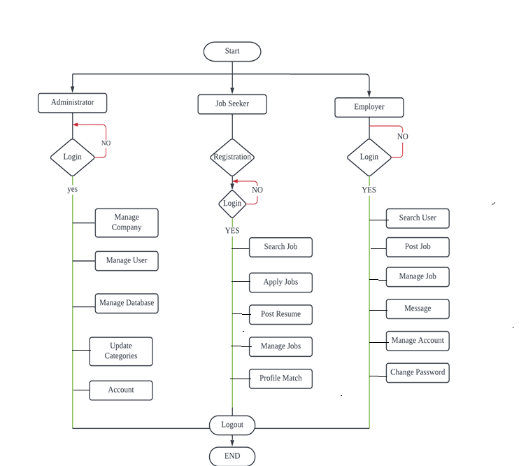

**DATA FLOW DIAGRAM:**

**DFD** is the abbreviation for **Data Flow Diagram**. The flow of data of a system or a process is represented by DFD. It also gives insight into the inputs and outputs of each entity and the process itself. DFD does not have control flow and no loops or decision rules are present. Specific operations depending on the type of data can be explained by a flowchart. Data Flow Diagram can be represented in several ways. The DFD belongs to structured-analysis modeling tools. Data Flow diagrams are very popular because they help us to visualize the major steps and data involved in software-system processes.

#### **Levels of DFD**

DFD uses hierarchy to maintain transparency thus multilevel DFD’s can be created. Levels of DFD are as follows:

* 0-level DFD
* 1-level DFD
* 2-level DFD

**Zero Level DFD:**

It is also known as a context diagram. It’s designed to be an abstraction view, showing the system as a single process with its relationship to external entities. It represents the entire system as a single bubble with input and output data indicated by incoming/outgoing arrows. It should be easily understood by a wide audience, including stakeholders, business analysts, data analysts and

Developers.

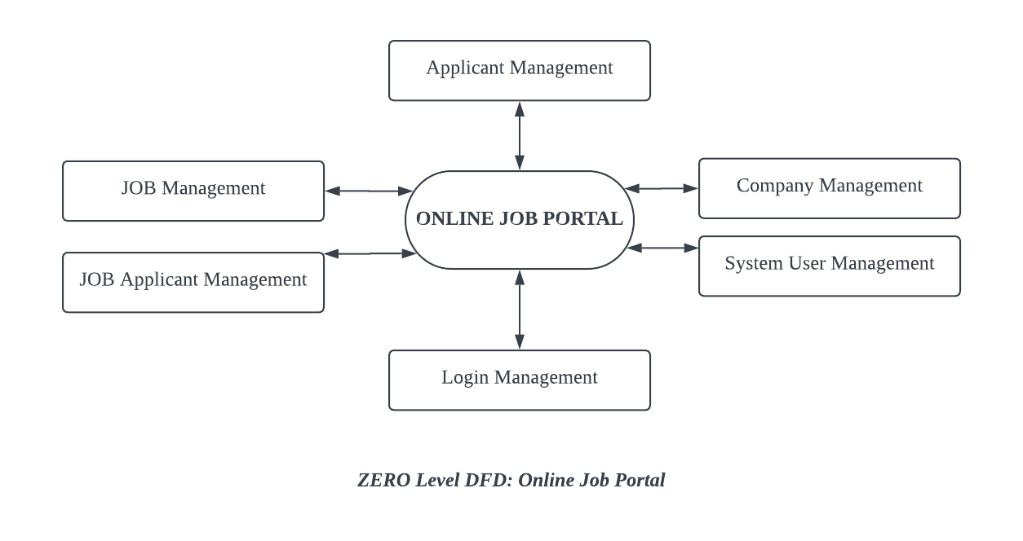

**First Level DFD:**

In 1-level DFD, the context diagram is decomposed into multiple bubbles/processes. In this level, we highlight the main functions of the system and breakdown the high-level process of 0-level DFD into sub processes.

Level 1 DFD also mentions basic processes and sources of information.

* It provides a more detailed view of the Context Level Diagram.
* Here, the main functions carried out by the system are highlighted as we break into its sub-processes.

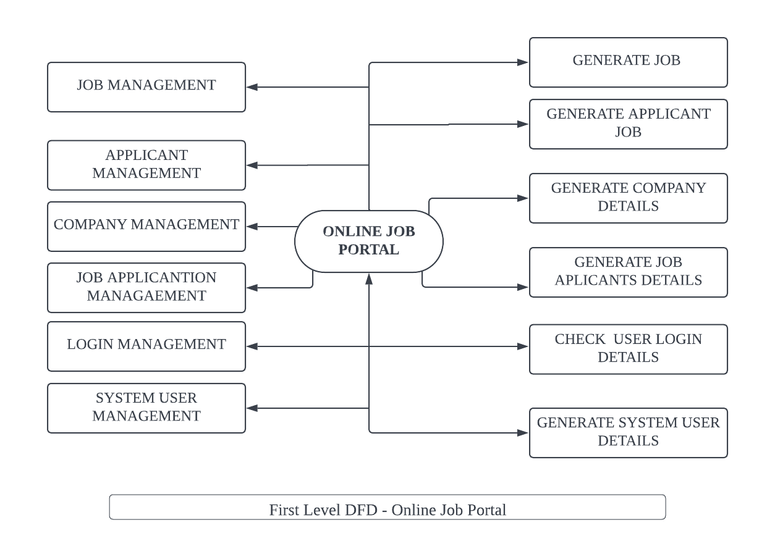

**Second Level DFD:**

Second-level DFD goes one step deeper into parts of 1-level DFD. It can be used to plan or record the specific/necessary detail about the system’s functioning.

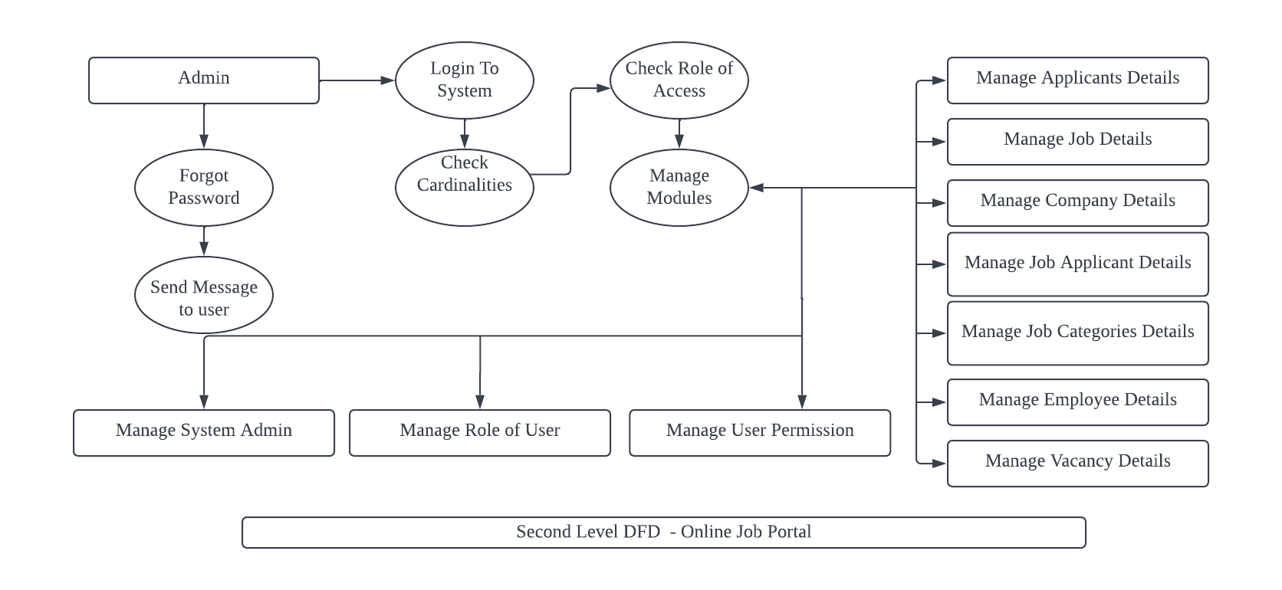

**USE CASE DIAGRAM:**

**ONLINE JOB PORTAL USE CASE DIAGRAM** – This diagram shows the specified sub-processes which were based on the main process.

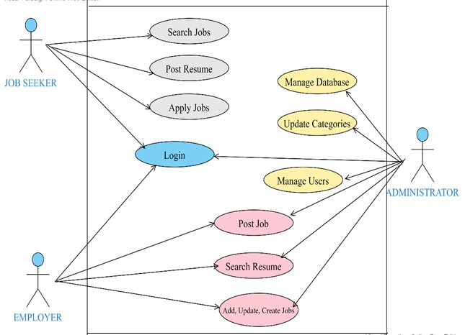

**SYSTEM IMPLEMENTATION:**

Systems implementation is a set of procedures performed to complete the design (as necessary) contained in the approved systems design document and to test, install, and begin to use the new or revised Information System. The systems implementation goals are as follows. For example, the detailed contents of new or revised documents, computer screens, and database must be laid out and created. Write, test, and document the programs and procedures required by the approved systems design document. Ensure, by completing the preparation of user manuals and other documentation and by training personnel, that the organizations personnel can operate the alumni system. Determine, by thoroughly testing the system with users, that the system satisfies the users requirements. Ensure a correct conversion by planning, controlling, and conducting an orderly installation of the new system.

**MODULE DESCRIPTION:**

This project has the following main modules:

* + - Administrator Module
    - Employer Module
    - Job Seeker Module

**MODULE DESCRIPTION:**

**1. Administrator Module:**

This module provides administrator related functionalities. Administrator manages entire application and maintain the profiles of applicants and employers.

**Facilities provided to Administrator:**

* + - Admin can add new companies.
    - Administrator can provide user-id and password to different users of the system.
    - Administrator can delete existing account.
    - Administrator can view or edit existing account.

**2. Employer Module:**

This Module provides functionalities related to employers. Employers can post vacancy details and update the details as and when necessary. Employers can search through applicant resumes based on different criteria.

**Facilities provided to Employer:**

* + - Employer can view Job seeker with particular skill set.
    - Employer can upload Job posts and documents that Job seeker can view.
    - Employer can answer all the queries of the Job Seeker regarding the job listed.

**3.Job Seeker Module:**

This Module provides functionalities for job seekers. Applicant can post their resumes with personal and professional details. They can also update the resume as frequently as required. The applicant can also browse through the present.

**Facilities provided to Employer:**

* + - A Job Seeker can search for different job opportunities.
    - A Job Seeker can post his/her resume.
    - A Job Seeker can view a particular company or list of companies.
    - A Job Seeker can contact companies directly at the contacts provided by them.

**DATABASE DESIGN**

## MySQL Database

* MySQL is released under an open-source license. So you have nothing to pay to use it.
* MySQL uses a standard form of the well-known SQL data language.
* MySQL works on many operating systems and with many languages including PHP, PERL, C, C++, JAVA, etc.
* MySQL works very quickly and works well even with large data sets.
* MySQL is very friendly to PHP, the most appreciated language for web development.
* MySQL supports large databases, up to 50 million rows or more in a table. The default file size limit for a table is 4GB, but you can increase this (if your operating system can handle it) to a theoretical limit of 8 million terabytes (TB).
* MySQL is customizable. The open-source GPL license allows programmers to modify the MySQL software to fit their own specific environments.

**DATABASE :**

**DATABASE NAME:** erisdb

|  |  |  |  |  |  |  |
| --- | --- | --- | --- | --- | --- | --- |
| **Table 1: Applicant** | | | | | | |
| **Name:** | | tblapplicants | | | | |
| **Description:** | | Records information regarding Applicants | | | | |
| **Fields** | | | | | | |
| **S. No** | **Field Name** | | | **Field Type** | **Description** | |
| 1 | APPLICANTID | | int | | | Name of the Applicant id |
| 2 | FNAME | | Varchar(50) | | | First Name of the Applicant |
| 3 | LNAME | | Varchar(50) | | | Last Name of the Applicant |
| 4 | ADDRESS | | Varchar(50) | | | Address of the Applicant |
| 5 | SEX | | Varchar(50) | | | Gender of the Applicant |
| 6 | CIVILSTATUS | | Varchar(50) | | | Civil Status of the Applicant |
| 7 | BIRTHDATE | | Date | | | DOB of the Applicant |
| 8 | BIRTHPLACE | | Varchar(50) | | | Birth Place of the Applicant |
| 9 | USERNAME | | Varchar(50) | | | Username of the Applicant |
| 10 | PASS | | Varchar(50) | | | Password of the Applicant |
| 11 | EMAILADDRESS | | Varchar(50) | | | Email of the Applicant |
| 12 | CONTACTNO | | Number | | | Phone Number of the Applicant |
| 13 | DEGREE | | Varchar(50) | | | Qualification of the Applicant |
| 14 | APPLICANTPHOTO | | Varchar(50) | | | Photo of the Applicant |

|  |  |  |  |  |  |
| --- | --- | --- | --- | --- | --- |
| **Table 2: Attachment Files** | | | | | |
| **Name:** | | tblattachmentfiles | | | |
| **Description:** | | Records information regarding Attachment Files | | | |
| **Fields** | | | | | |
| **S. No** | **Field Name** | | **Field Type** | **Description** | |
| 1 | ID | | int | | Id of the Attachment files |
| 2 | FILEID | | Varchar(50) | | File Id of the Attachment files |
| 3 | JOBID | | Varchar(50) | | Job Id of the Applicant |
| 4 | FILE_NAME | | Varchar(50) | | Resume of the Applicant |
| 5 | FILE_LOCATION | | Varchar(50) | | Resume Location |

|  |  |  |  |  |  |
| --- | --- | --- | --- | --- | --- |
| **Table 3: Category** | | | | | |
| **Name:** | | tblcategory | | | |
| **Description:** | | Records information regarding Category | | | |
| **Fields** | | | | | |
| **S. No** | **Field Name** | | **Field Type** | **Description** | |
| 1 | CATEGORYID | | int | | Id of the Category Jobs |
| 2 | CATEGORY | | Varchar(50) | | Jobs Category Name |

|  |  |  |  |  |  |
| --- | --- | --- | --- | --- | --- |
| **Table 4: Company** | | | | | |
| **Name:** | | tblcompany | | | |
| **Description:** | | Records information regarding Company | | | |
| **Fields** | | | | | |
| **S. No** | **Field Name** | | **Field Type** | **Description** | |
| 1 | COMPANYID | | int | | Id of t |
| 2 | COMPANYNAME | | Varchar(50) | | Name Of the Company |
| 3 | COMPANYADDRESS | | Varchar(50) | | Job Id of the Applicant |
| 4 | COMPANYCONTACTNO | | Varchar(50) | | Resume of the Applicant |

|  |  |  |  |  |  |  |
| --- | --- | --- | --- | --- | --- | --- |
| **Table 5: Employees** | | | | | | |
| **Name:** | | tblemployees | | | | |
| **Description:** | | Records information regarding Employees | | | | |
| **Fields** | | | | | | |
| **S. No** | **Field Name** | | | **Field Type** | **Description** | |
| 1 | EMPLOYEEID | | int | | | Name of the Employee id |
| 2 | FNAME | | Varchar(50) | | | First Name of the Employee |
| 3 | LNAME | | Varchar(50) | | | Last Name of the Employee |
| 4 | MNAME | | Varchar(50) | | | Middle Name of the Employee |
| 5 | BIRTHDATE | | Date | | | DOB of the Employee |
| 6 | BIRTHPLACE | | Varchar(50) | | | Birth Place of the Employee |
| 7 | AGE | | INT | | | Age of the Employee |
| 8 | SEX | | Varchar(50) | | | Gender of the Employee |
| 9 | CIVILSTATUS | | Varchar(50) | | | Civil Status of the Employee |
| 10 | TELLNO | | Varchar(50) | | | Phone Number of the Employee |
| 11 | EMP_EMAILADDRESS | | Varchar(50) | | | Email of the Employee |
| 12 | POSITION | | Number | | | Position of the Employee |
| 13 | EMPUSERNAME | | Varchar(50) | | | Username of the Employee |
| 14 | EMPPASSWORD | | Varchar(50) | | | Password of the Employee |
| 15 | DATEHIRED | | Varchar(50) | | | Hired Date of the Employee |
| 16 | COMPANYID | | Int | | |  |

|  |  |  |  |  |  |  |
| --- | --- | --- | --- | --- | --- | --- |
| **Table 6: Users** | | | | | | |
| **Name:** | | tblusers | | | | |
| **Description:** | | Records information regarding Users | | | | |
| **Fields** | | | | | | |
| **S. No** | **Field Name** | | | **Field Type** | **Description** | |
| 1 | USERID | | int | | | Id of the User |
| 2 | FULLNAME | | Varchar(50) | | | Full Name of the User |
| 3 | USERNAME | | Varchar(50) | | | Username |
| 4 | PASSWORD | | Varchar(50) | | | Password of the User |
| 4 | ROLE | | Varchar(50) | | | Role of the User |
| 5 | PICLOCATION | | Varchar(50) | | | Picture location of the User Profile |

|  |  |  |  |  |
| --- | --- | --- | --- | --- |
| **Table 7: Jobs** | | | | |
| **Name:** | | tbljobs | | |
| **Description:** | | Records information regarding Jobs | | |
| **Fields** | | | | |
| **S. No** | **Field Name** | | **Field Type** | **Description** |
| 1 | JOBID | | int | Id of the Job |
| 2 | COMPANYID | | Varchar(50) | Company Id |
| 3 | CATEGORY | | Varchar(50) | Last Name of the Employee |
| 4 | OCCUPATIONTITLE | | Varchar(50) | Occupation Title |
| 5 | REQ_NO_EMPLOYEES | | Date | Required No. Employees |
| 6 | SALARIES | | Varchar(50) | Salary of the Applicant |
| 7 | DURATION_EMPLOYMENT | | INT | Job Duration |
| 8 | WORK_QUALIFICATION | | Varchar(50) | Qualification and Experience of Job Seeker |
| 9 | JOBDESCRIPTION | | Varchar(50) | Description of the Job |
| 10 | PREFERREDSEX | | Varchar(50) | Preferred Sex for Job |
| 11 | LAST_DATE | | Varchar(50) | Applicant Applied for last Date |
| 12 | POSITION | | Number | Position of the Employee |
| 13 | DATEPOSTED | | Varchar(50) | Posted Date of the Job |
| 14 | JOBTYPE | | Varchar(50) | Type of the Job |
| 15 | COMPANYID | | Int |  |

|  |  |  |  |  |  |  |
| --- | --- | --- | --- | --- | --- | --- |
| **Table 8: Job Registration** | | | | | | |
| **Name:** | | tbljobregistration | | | | |
| **Description:** | | Records information regarding Job Registration | | | | |
| **Field** | | | | | | |
| **S. No** | **Field Name** | | | **Field Type** | **Description** | |
| 1 | REGISTRATIONID | | Int | | | Id of the Registration |
| 2 | COMPANYID | | Int | | | Id of the Company |
| 3 | JOBID | | Int | | | Id of the Job |
| 4 | APPLICANTID | | Int | | | Id of the Applicant |
| 5 | APPLICANT | | Varchar(50) | | | Name of the Applicant |
| 6 | REGISTRATIONDATE | | Date | | | Registration date of the Applicant |
| 7 | REMARKS | | Varchar(50) | | | Remarks of the Applicant |
| 8 | FILEID | | Varchar(50) | | | Id of the File |
| 9 | PENDINGAPPLICATION | | Int | | | Application Pending |
| 10 | DATETIMEAPPROVED | | Datetime | | | Approval of date and time |

**HOME PAGE**



**COMPANY:**

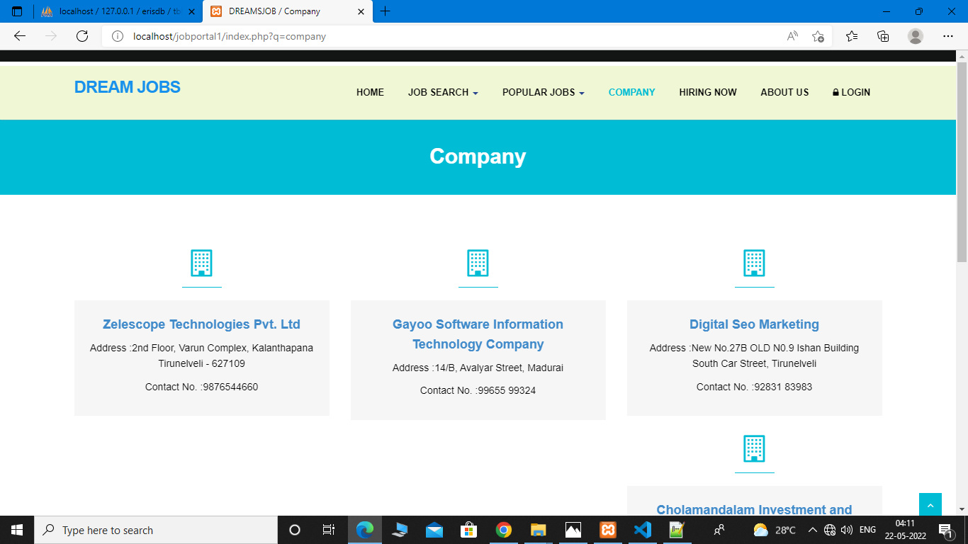

**GOVERNMENT JOBS:**

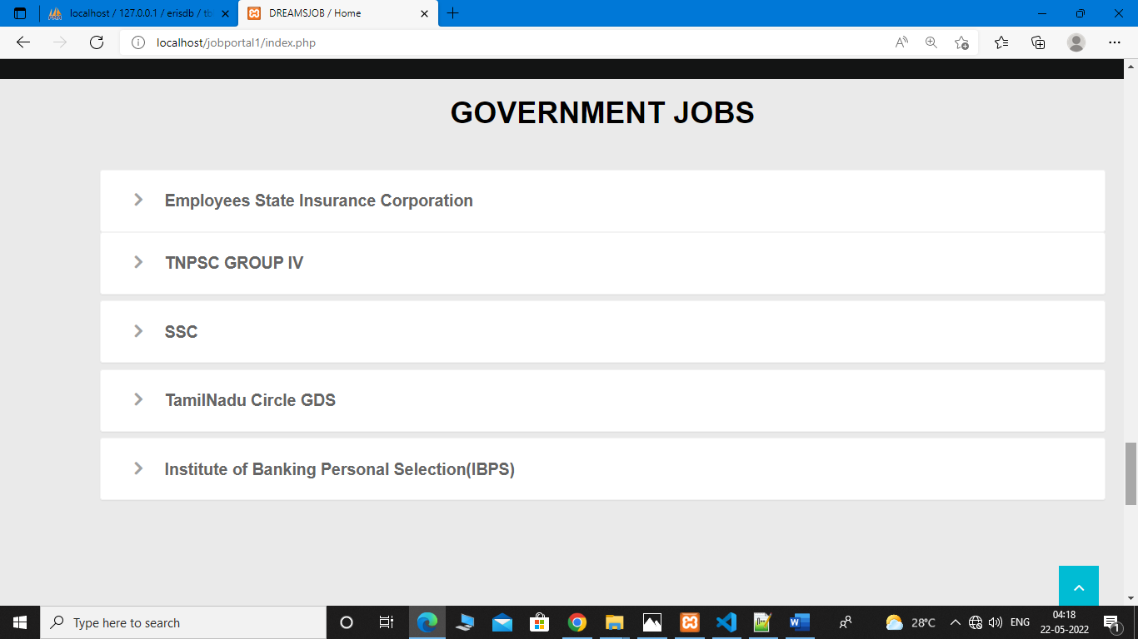

**POPULAR JOBS:**

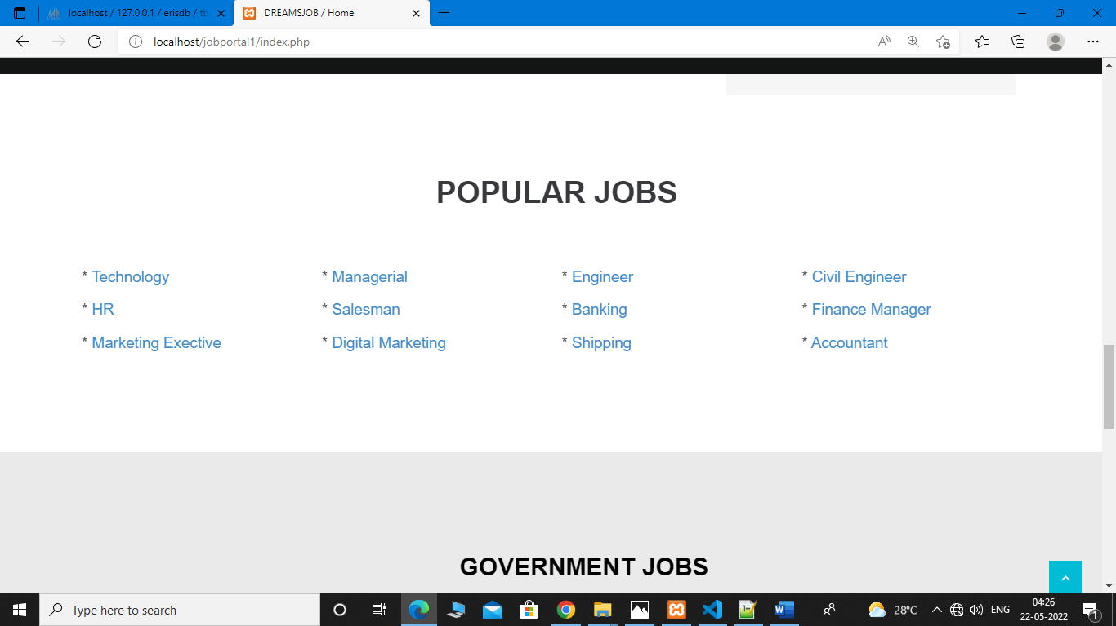

**HIRING NOW:**

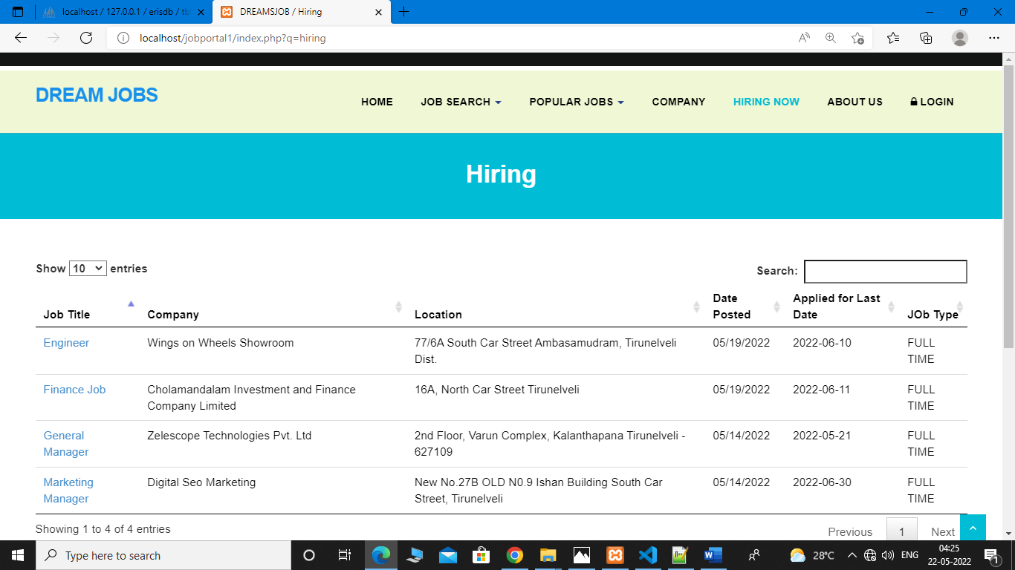

**JOB DETAILS:**

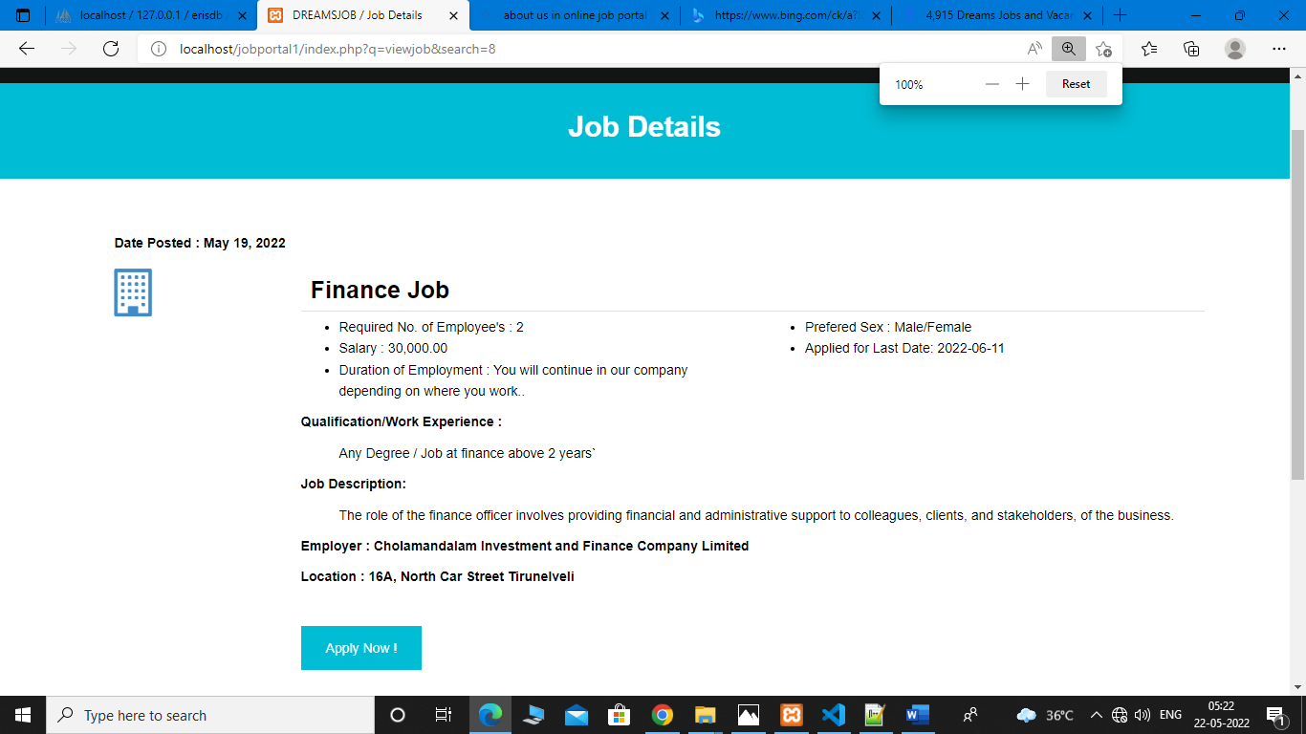

**USER PERSONAL INFORMATION:**

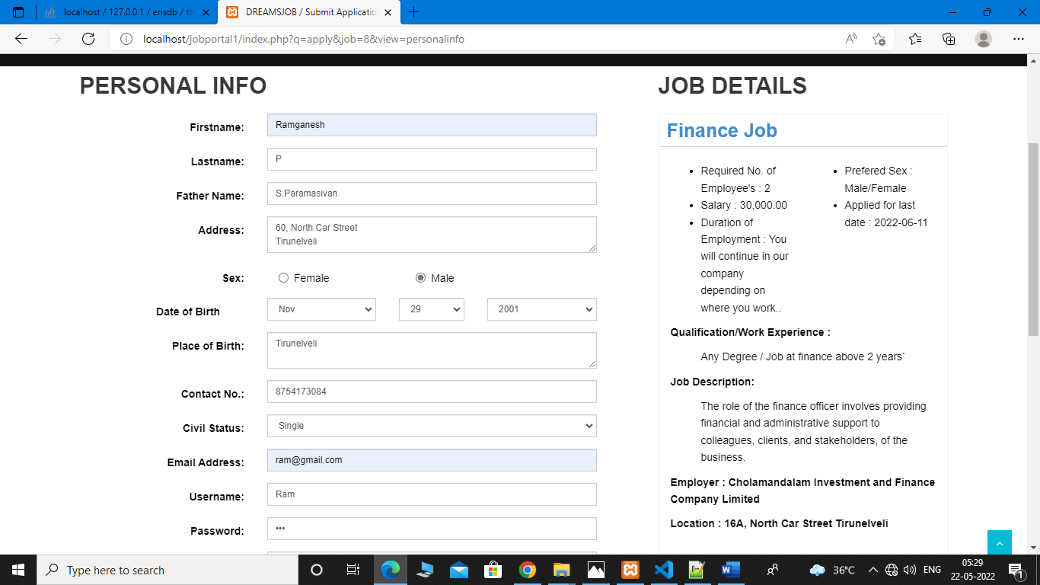

**APPLICATION SUBMITTED:**

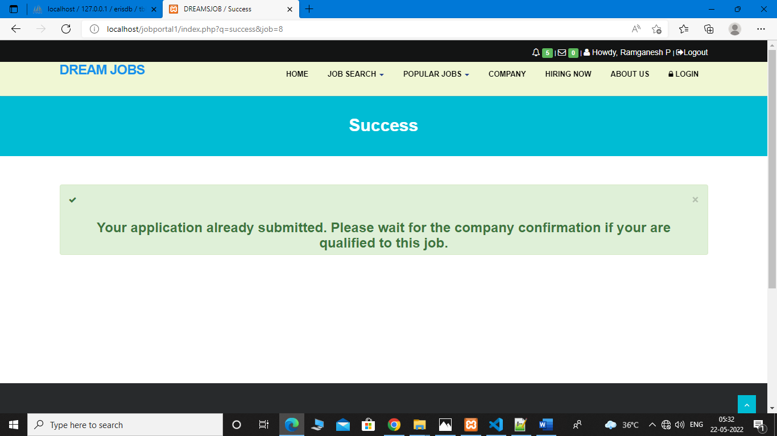

**USER LOGIN:**

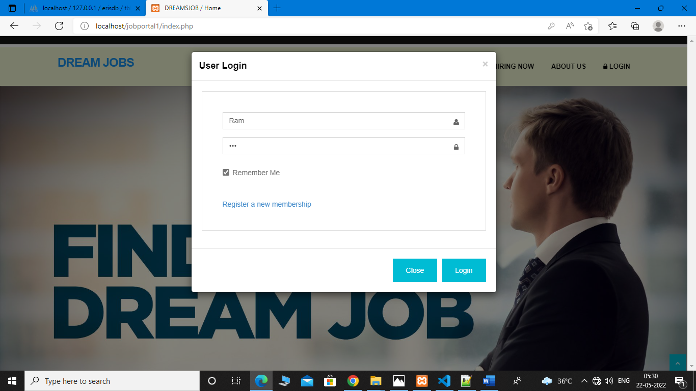

**USER PROFILE:**

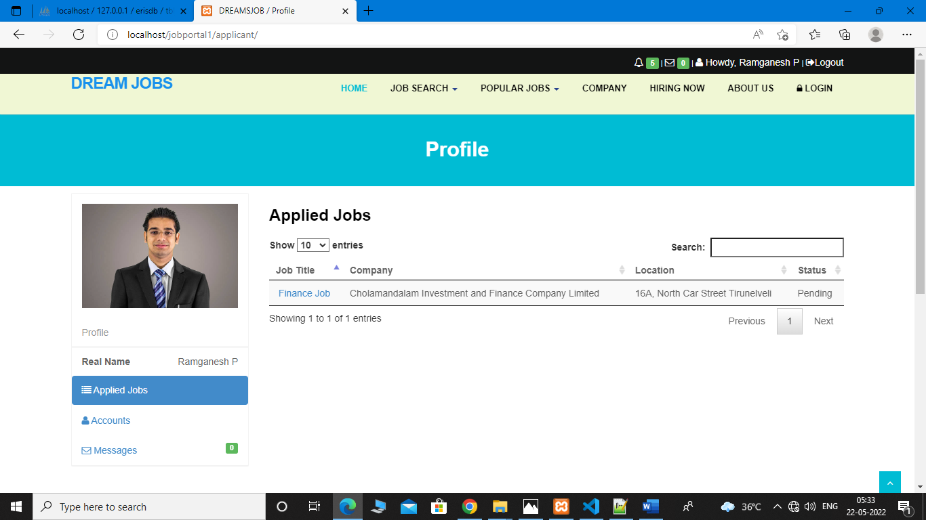

**ADMIN/ STAFF LOGIN:**

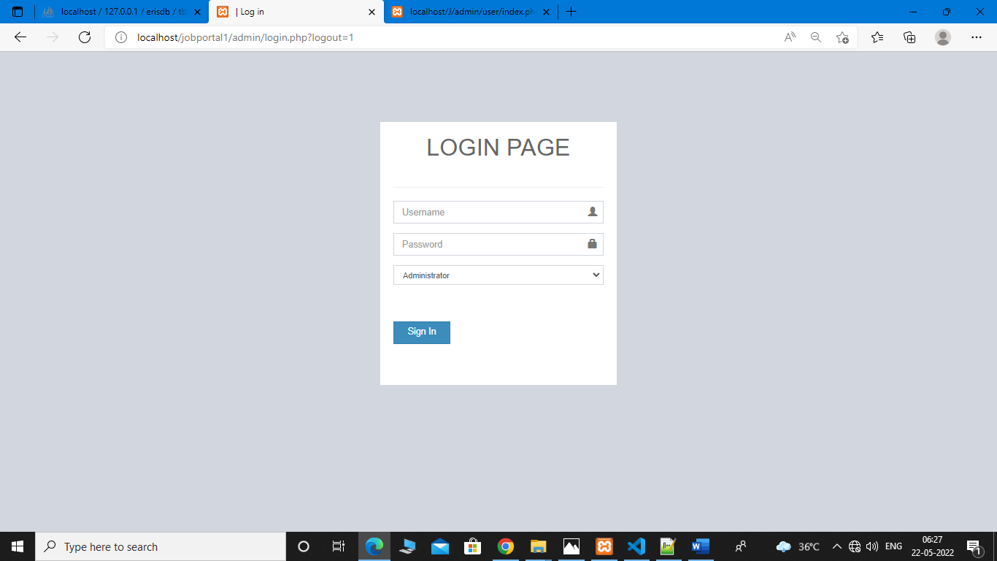

**ADMIN DASHBOARD:**

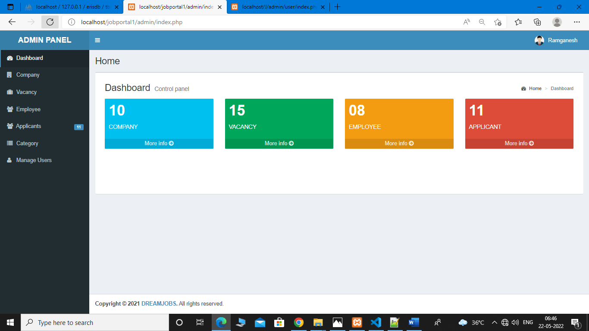

**ADMIN PROFILE:**

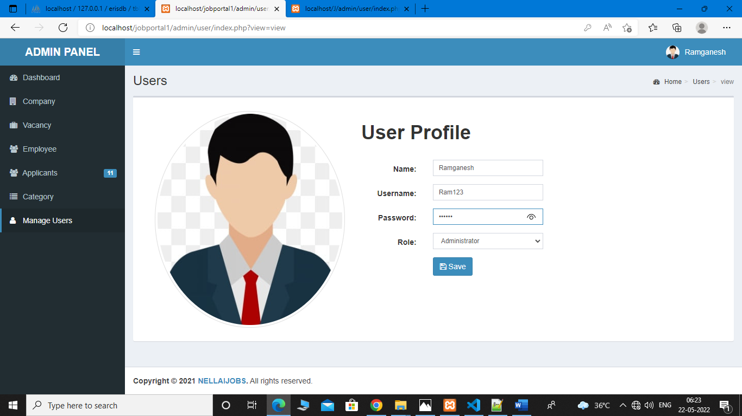

**COMPANY DETAILS:**

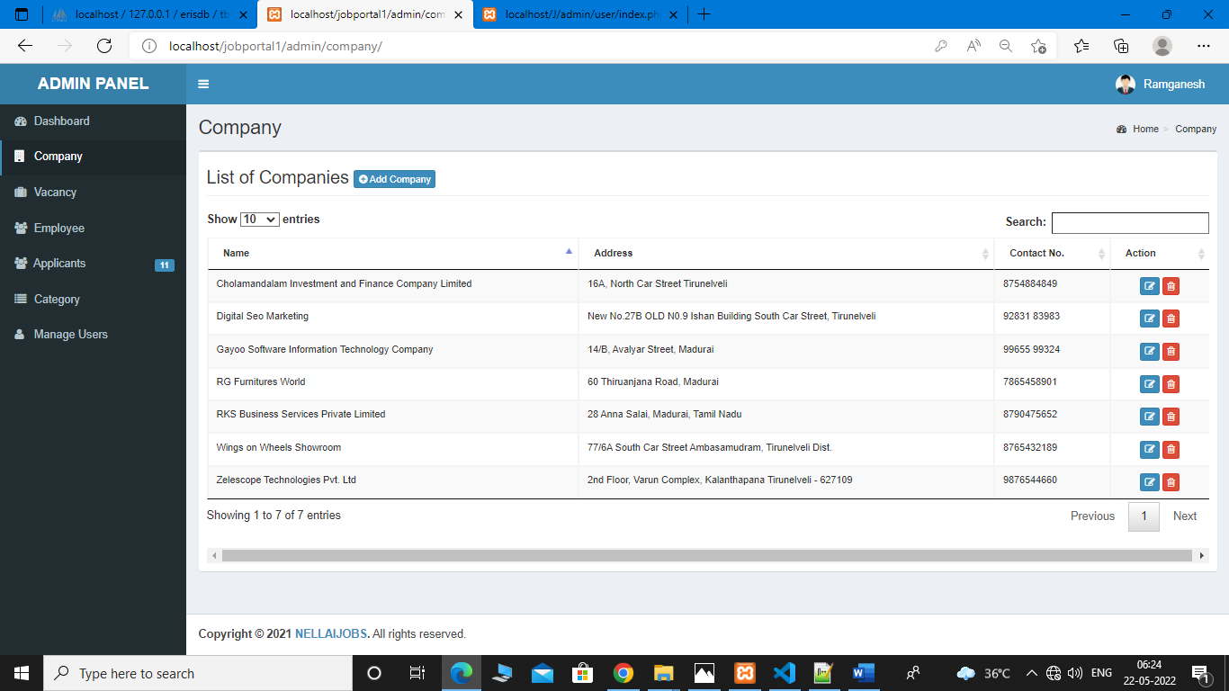

**VACANY DETAILS:**

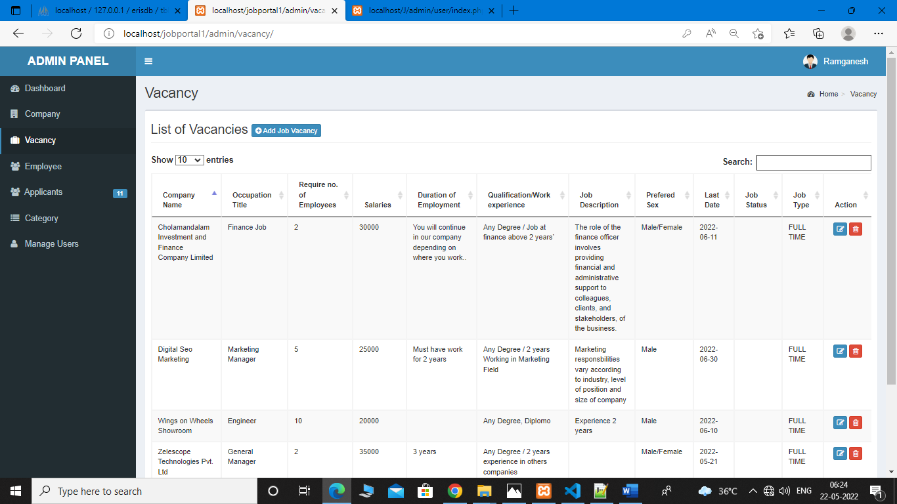

**Employee Details:**

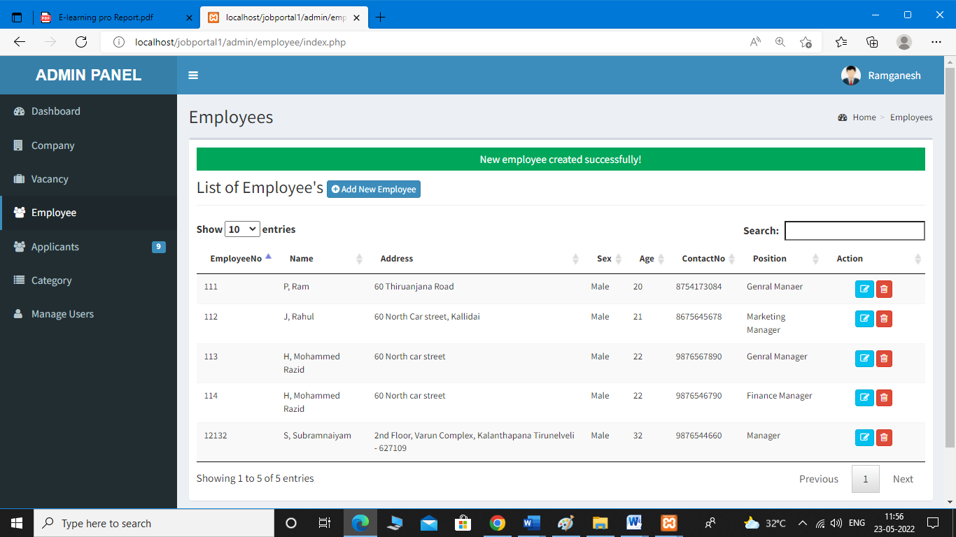

**Applicants Details:**

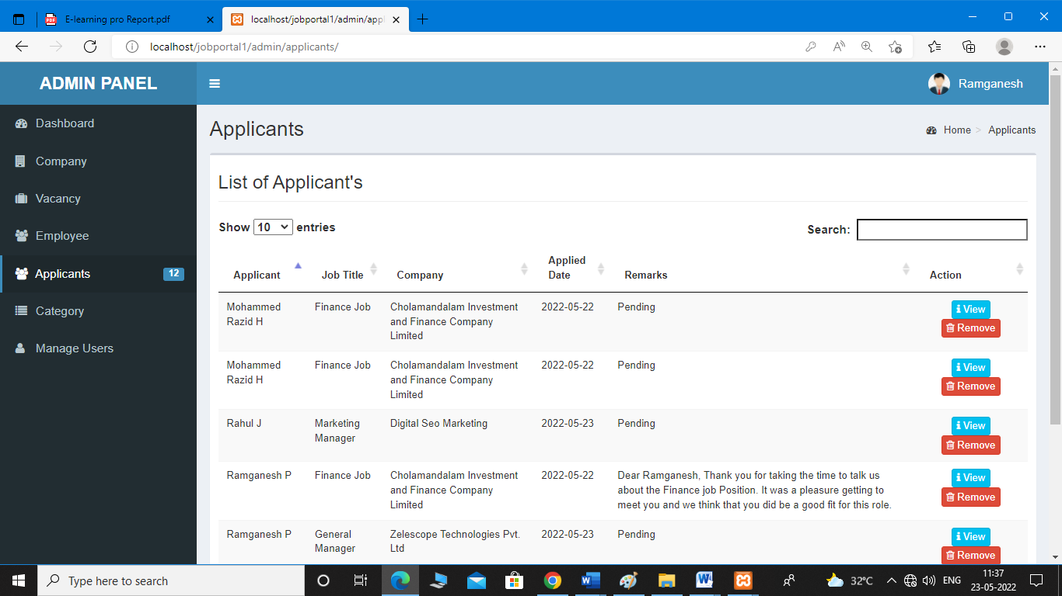

**CATEGORY DETAILS:**

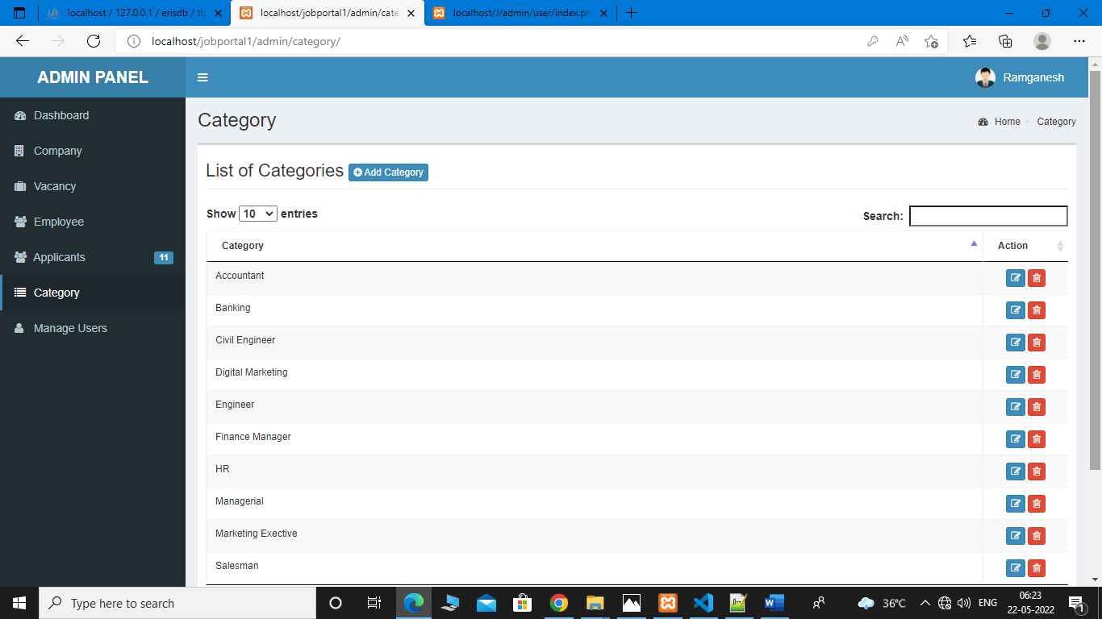

**VIEW THE APPLICANT DETAILS:**

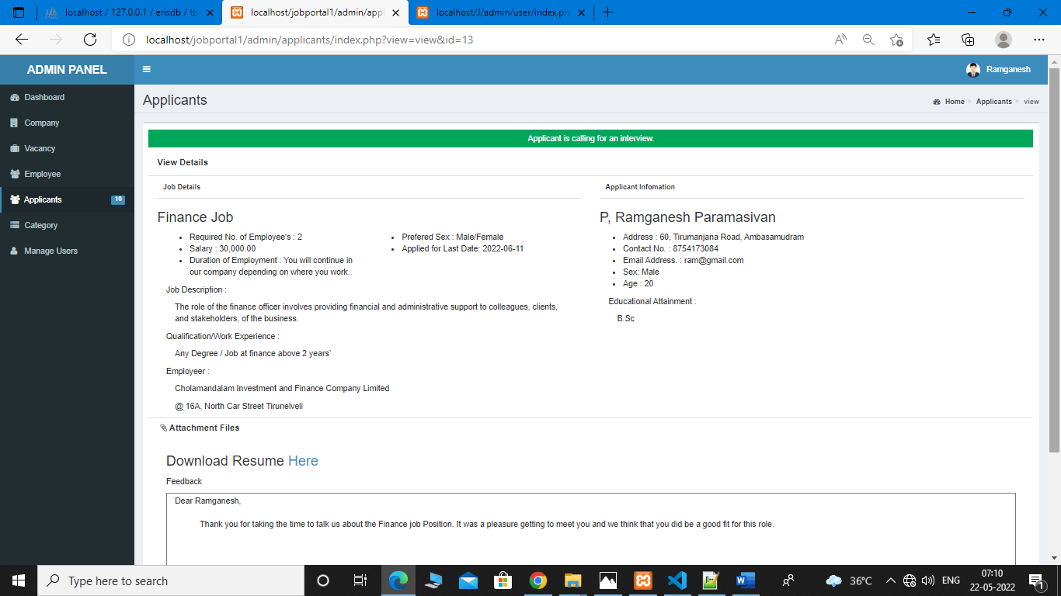

**SELECTED FOR JOB SEEKER:**

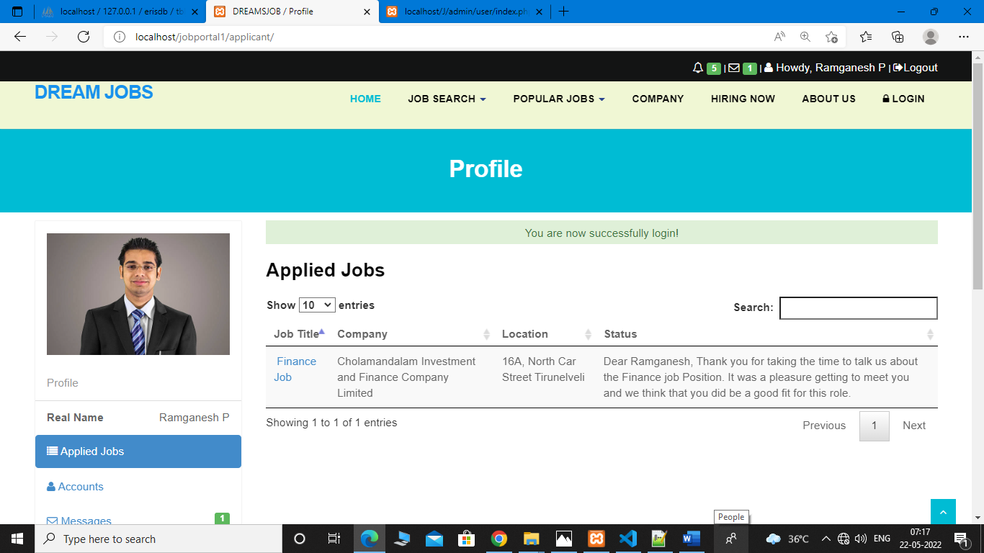

**SAMPLE CODE:**

**Home.php**

<section id="banner">

<!-- Slider -->

<div id="main-slider" class="flexslider">

<ul class="slides">

<li>

<img src="<?php echo web_root; ?>plugins/home-plugins/img/slides/img5.jpg" alt="" />

</li>

</ul>

</div>

<!-- end slider -->

</section>

<section id="content">

<div class="container">

<div class="row">

<div class="col-md-12">

<div class="aligncenter"><h2 class="aligncenter">Company</h2><!-- Lorem ipsum dolor sit amet, consectetur adipisicing elit. Dolores quae porro consequatur aliquam, incidunt eius magni provident, doloribus omnis minus ovident, doloribus omnis minus temporibus perferendis nesciunt.. --></div>

<br/>

</div>

</div>

<?php

$sql = "SELECT * FROM `tblcompany`";

$mydb->setQuery($sql);

$comp = $mydb->loadResultList();

foreach ($comp as $company ) {

# code...

?>

<div class="col-sm-4 info-blocks">

<i class="icon-info-blocks fa fa-building-o"></i>

<div class="info-blocks-in">

<h3><?php echo $company->COMPANYNAME;?></h3>

<!-- <p><?php echo $company->COMPANYMISSION;?></p> -->

<p>Address :<?php echo $company->COMPANYADDRESS;?></p>

<p>Contact No. :<?php echo $company->COMPANYCONTACTNO;?></p>

</div>

</div>

<?php } ?>

</div>

</section>

<section class="section-padding gray-bg">

<div class="container">

<div class="row">

<div class="col-md-12">

<div class="section-title text-center">

<h2 >Popular Jobs</h2>

</div>

</div>

</div>

<div class="row">

<div class="col-md-12 ">

<?php

$sql = "SELECT * FROM `tblcategory`";

$mydb->setQuery($sql);

$cur = $mydb->loadResultList();

foreach ($cur as $result) {

echo '<div class="col-md-3" style="font-size:15px;padding:5px">* <a href="'.web_root.'index.php?q=category&search='.$result->CATEGORY.'">'.$result->CATEGORY.'</a></div>';

}

?>

</div>

</div>

</div>

</section>

<section id="content-3-10" class="content-block data-section nopad content-3-10">

<div class="image-container col-sm-6 col-xs-12 pull-left">

</div>

<div class="container-fluid">

<div class="row">

<div class="col-sm-15 col-sm-offset-44 col-xs-12 content">

<div class="col-md-15">

<div class="block-heading-two">

<center><h3><span>GOVERNMENT JOBS</span></h3></center>

</div> <div class="panel-group" id="accordion-alt3">

<!-- Panel. Use "panel-XXX" class for different colors. Replace "XXX" with color. -->

<div class="panel">

<!-- Panel heading -->

<div class="panel-heading">

<h4 class="panel-title">

<a data-toggle="collapse" data-parent="#accordion-alt3" href="#collapseOne-alt3">

<i class="fa fa-angle-right"></i> Employees State Insurance Corporation

</a>

</h4>

</div>

<div id="collapseOne-alt3" class="panel-collapse collapse">

<!-- Panel body -->

<div class="panel-body"> <li>

<p>Click Here:

<a href="https://www.esic.nic.in/">[https://www.esic.nic.in/</a](https://www.esic.nic.in/%3c/a)>

</p></li>

Salary: 70,000<BR>

Vacancy: 6000<BR>

Duration Date: 7/4/2022 to 21/4/2022<br>

Qualification: 12th pass<br>

Name of the Post: Officer,MPS,UDC<br>

Payment of Exam Fees: 100

</div>

</div>

</div>

<!-- Accordion starts -->

<div class="panel-group" id="accordion-alt3">

<!-- Panel. Use "panel-XXX" class for different colors. Replace "XXX" with color. -->

<div class="panel">

<!-- Panel heading -->

<div class="panel-heading">

<h4 class="panel-title">

<a data-toggle="collapse" data-parent="#accordion-alt3" href="#collapseOne-alt3">

<i class="fa fa-angle-right"></i> TNPSC GROUP IV

</a>

</h4>

</div>

<div id="collapseOne-alt3" class="panel-collapse collapse">

<!-- Panel body -->

<div class="panel-body">

<li><p>Click Here:<ahref="https://www.tnpsc.gov.in/">https://www.tnpsc.gov.in/</a></p></li>

Salary:7 0,000<BR>

Vacancy: 6000<BR>

Qualification: Any Degree<br>

Duration Date: 7/4/2022 to 21/4/2022<br>

Name of the Post: VAO,Typist,Bill Collector etc....<br>

Payment of Exam Fees: 100

</div>

</div>

</div>

<div class="panel">

<div class="panel-heading">

<h4 class="panel-title">

<a data-toggle="collapse" data-parent="#accordion-alt3" href="#collapseTwo-alt3">

<i class="fa fa-angle-right"></i> SSC

</a>

</h4>

</div>

<div id="collapseTwo-alt3" class="panel-collapse collapse">

<div class="panel-body">

<li><p>Click Here:<a href="https://ssc.nic.in/">https://ssc.nic.in/</a></p></li>

Salary:18,000 to 22,000<BR>

Vacancy: 7099<BR>

Qualification: Any Degree<br>

Duration Date: 22/3/2022 to 30/4/2022<br>

Name of the Post: MTS<br>

Payment of Exam Fees: Male:100 / Female: Exemption

</div>

</div>

</div>

<div class="panel">

<div class="panel-heading">

<h4 class="panel-title">

<a data-toggle="collapse" data-parent="#accordion-alt3" href="#collapseThree-alt3">

<i class="fa fa-angle-right"></i> TamilNadu Circle GDS

</a>

</h4>

</div>

<div id="collapseThree-alt3" class="panel-collapse collapse">

<div class="panel-body">

<li><p>Click Here:<a href="https://indiapostgdsonline.gov.in/">https://indiapostgdsonline.gov.in/</a></p></li>

Salary:10,000 to 14,000<BR>

Vacancy: 6162<BR>

Qualification: Any Degree<br>

Duration Date: 02/05/2022 to 05/06/2022<br>

Name of the Post: Post Master<br>

Payment of Exam Fees: Male:100 / Female: Exemption

</div>

</div>

</div>

<div class="panel">

<div class="panel-heading">

<h4 class="panel-title">

<a data-toggle="collapse" data-parent="#accordion-alt3" href="#collapseFour-alt3">

<i class="fa fa-angle-right"></i> Institute of Banking Personal Selection(IBPS)

</a>

</h4>

</div>

<div id="collapseFour-alt3" class="panel-collapse collapse">

<div class="panel-body">

<li><p>Click Here:<a href="https://ibpsonline.ibps.in/">"https://ibpsonline.ibps.in/</a></p></li>

Salary:28,000 to 30,000<BR>

Vacancy: 5,830<BR>

Qualification: Any Degree<br>

Duration Date: 22/3/2022 to 30/4/2022<br>

Name of the Post: Clerk<br>

Payment of Exam Fees: Male:100 / Female: Exemption

</div>

</div>

</div>

</div>

</div>

</div>

</div>

</div><!-- /.row-->

</div><!-- /.container -->

<br><br>

</section>

<div class="about home-about">

<div class="container">

<div class="row">

<div class="col-md-4">

<!-- Heading and para -->

</div>

</div>

</div

</div

</div>

**Admin_home.php**

<section class="content-header">

<h1>

Dashboard

<small>Control panel</small>

</h1>

<ol class="breadcrumb">

<li><a href="#"><i class="fa fa-dashboard"></i> Home</a></li>

<li class="active">Dashboard</li>

</ol>

</section>

<!-- Main content -->

<section class="content">

<!-- Small boxes (Stat box) -->

<div class="row">

<div class="col-lg-3 col-xs-6">

<!-- small box -->

<div class="small-box bg-aqua">

<div class="inner">

<h3>10</h3>

<p>COMPANY</p>

</div>

<div class="icon">

<i class="ion ion-bag"></i>

</div>

<a href="#" class="small-box-footer">More info <i class="fa fa-arrow-circle-right"></i></a>

</div>

</div>

<!-- ./col -->

<div class="col-lg-3 col-xs-6">

<!-- small box -->

<div class="small-box bg-green">

<div class="inner">

<h3>15<sup style="font-size: 20px"></sup></h3>

<p>VACANCY</p>

</div>

<div class="icon">

<i class="ion ion-stats-bars"></i>

</div>

<a href="#" class="small-box-footer">More info <i class="fa fa-arrow-circle-right"></i></a>

</div>

</div>

<!-- ./col -->

<div class="col-lg-3 col-xs-6">

<!-- small box -->

<div class="small-box bg-yellow">

<div class="inner">

<h3>08</h3>

<p>EMPLOYEE</p>

</div>

<div class="icon">

<i class="ion ion-person-add"></i>

</div>

<a href="#" class="small-box-footer">More info <i class="fa fa-arrow-circle-right"></i></a>

</div>

</div>

<!-- ./col -->

<div class="col-lg-3 col-xs-6">

<!-- small box -->

<div class="small-box bg-red">

<div class="inner">

<h3>11</h3>

<p>APPLICANT</p>

</div>

<div class="icon">

<i class="ion ion-pie-graph"></i>

</div>

<a href="#" class="small-box-footer">More info <i class="fa fa-arrow-circle-right"></i></a>

</div>

</div>

<!-- ./col -->

</div>

<!-- /.row -->

<!-- Main row -->

<div class="row">

**applicant.php**

<div class="form-group">

<div class="col-md-11">

<label class="col-md-4 control-label" for=

"FNAME">Firstname:</label>

<div class="col-md-8">

<input name="JOBID" type="hidden" value="<?php echo $_GET['job'];?>">

<input class="form-control input-sm" id="FNAME" name="FNAME" placeholder="Firstname" type="text" value="" onkeyup="javascript:capitalize(this.id, this.value);" autocomplete="off">

</div>

</div>

</div>

<div class="form-group">

<div class="col-md-11">

<label class="col-md-4 control-label" for="LNAME">Lastname:</label>

<div class="col-md-8">

<input name="deptid" type="hidden" value="">

<input class="form-control input-sm" id="LNAME" name="LNAME" placeholder="Lastname" onkeyup=

"javascript:capitalize(this.id, this.value);" autocomplete="off">

</div>

</div>

</div>

<div class="form-group">

<div class="col-md-11">

<label class="col-md-4 control-label" for=

"MNAME">Father Name:</label>

div class="col-md-8">

<input name="deptid" type="hidden" value="">

<input class="form-control input-sm" id="MNAME" name="MNAME" placeholder="Father Name" onkeyup="javascript:capitalize(this.id, this.value);" autocomplete="off">

</div>

</div>

</div>

<div class="form-group">

<div class="col-md-11">

<label class="col-md-4 control-label" for"ADDRESS">Address:</label>

<div class="col-md-8">

<textarea class="form-control input-sm" id="ADDRESS" name="ADDRESS" placeholder=

"Address" type="text" value="" required onkeyup="javascript:capitalize(this.id, this.value);" autocomplete="off"></textarea>

</div>

</div>

</div>

<div class="form-group">

<div class="col-md-11">

<label class="col-md-4 control-label" for=

"Gender">Sex:</label>

<div class="col-md-8">

<div class="col-lg-5">

<div class="radio">

<label><input checked id="optionsRadios1" checked="True" name="optionsRadios" type="radio" value="Female">Female</label>

</div>

</div>

<div class="col-lg-4">

<div class="radio">

<label><input id="optionsRadios2" name="optionsRadios" type="radio" value="Male"> Male</label>

</div>

</div>

</div>

</div>

</div>

<div class="form-group">

<div class="rows">

<div class="col-md-11">

<div class="col-md-4">

<label class="col-lg-11 control-label">Date of Birth</label>

</div>

<div class="col-lg-3">

<select class="form-control input-sm" name="month">

<option>Month</option>

<?php

$mon = array('Jan' => 1 ,'Feb'=> 2,'Mar' => 3 ,'Apr'=> 4,'May' => 5 ,'Jun'=> 6,'Jul' => 7 ,'Aug'=> 8,'Sep' => 9 ,'Oct'=> 10,'Nov' => 11 ,'Dec'=> 11 );

foreach ($mon as $month => $value ) {

# code...

echo '<option value='.$value.'>'.$month.'</option>';

}

?>

</select>

</div>

<div class="col-lg-2">

<select class="form-control input-sm" name="day">

<option>Day</option>

<?php

$d = range(31, 1);

foreach ($d as $day) {

echo '<option value='.$day.'>'.$day.'</option>';

}

?>

</select>

</div>

<div class="col-lg-3">

<select class="form-control input-sm" name="year">

<option>Year</option>

<?php

$years = range(2010, 1900);

foreach ($years as $yr) {

echo '<option value='.$yr.'>'.$yr.'</option>';

}

?>

</select>

</div>

</div>

</div>

</div>

<div class="form-group">

<div class="col-md-11">

<label class="col-md-4 control-label" for=

"BIRTHPLACE">Place of Birth:</label>

<div class="col-md-8">

<textarea class="form-control input-sm" id="BIRTHPLACE" name="BIRTHPLACE" placeholder=

"Place of Birth" type="text" value="" required onkeyup="javascript:capitalize(this.id, this.value);" autocomplete="off"></textarea>

</div>

</div>

</div>

<div class="form-group">

<div class="col-md-11">

<label class="col-md-4 control-label" for=

"TELNO">Contact No.:</label>

<div class="col-md-8">

<input class="form-control input-sm" id="TELNO" name="TELNO" placeholder=

"Contact No." type="text" any value="" required onkeyup="javascript:capitalize(this.id, this.value);" autocomplete="off">

</div>

</div>

</div>

<div class="form-group">

<div class="col-md-11">

<label class="col-md-4 control-label" for=

"CIVILSTATUS">Civil Status:</label>

<div class="col-md-8">

<select class="form-control input-sm" name="CIVILSTATUS" id="CIVILSTATUS">

<option value="none" >Select</option>

<option value="Single">Single</option>

<option value="Married">Married</option>

<option value="Widow" >Widow</option>

<!-- <option value="Fourth" >Fourth</option> -->

</select>

</div>

</div>

</div>

<div class="form-group">

<div class="col-md-11">

<label class="col-md-4 control-label" for=

"EMAILADDRESS">Email Address:</label>

<div class="col-md-8">

<input type="Email" class="form-control input-sm" id="EMAILADDRESS" name="EMAILADDRESS" placeholder="Email Address" autocomplete="false"/>

</div>

</div>

</div>

<div class="form-group">

<div class="col-md-11">

<label class="col-md-4 control-label" for=

"USERNAME">Username:</label>

<div class="col-md-8">

<input name="deptid" type="hidden" value="">

<input class="form-control input-sm" id="USERNAME" name="USERNAME" placeholder=

"Username" onkeyup="javascript:capitalize(this.id, this.value);" autocomplete="off">

</div>

</div>

</div>

<div class="form-group">

<div class="col-md-11">

<label class="col-md-4 control-label" for=

"PASS">Password:</label>

<div class="col-md-8">

<input name="deptid" type="hidden" value="">

<input class="form-control input-sm" id="PASS" name="PASS" placeholder=

"Password" type="password" onkeyup="javascript:capitalize(this.id, this.value);" autocomplete="off">

<!-- <input class="form-control input-sm" id="DEPARTMENT_DESC" name="DEPARTMENT_DESC" placeholder=

"Description" type="text" value=""> -->

</div>

</div>

</div>

<div class="form-group">

<div class="col-md-11">

<label class="col-md-4 control-label" for=

"DEGREE">Educational Attainment:</label>

<div class="col-md-8">

<input name="deptid" type="hidden" value="">

<input class="form-control input-sm" id="DEGREE" name="DEGREE" placeholder=

"Educational Attainment" onkeyup="javascript:capitalize(this.id, this.value);" autocomplete="off">

</div>

</div>

</div>

<div class="form-group">

<div class="col-md-11">

<label class="col-md-4 control-label" for=

"d"></label>

<div class="col-md-8">

<label><input type="checkbox"> By Sign up you are agree with our <a href="#">terms and condition</a></label>

</div>

</div>

</div>

**Viewjob.php**

<section id="content">

<div class="container content">

<?php

if (isset($_GET['search'])) {

# code...

$jobid = $_GET['search'];

}else{

$jobid = '';

}

$sql = "SELECT * FROM `tblcompany` c,`tbljob` j WHERE c.`COMPANYID`=j.`COMPANYID` AND JOBID LIKE '%" . $jobid ."%' ORDER BY DATEPOSTED DESC" ;

$mydb->setQuery($sql);

$cur = $mydb->loadResultList();

foreach ($cur as $result) {

?>

<div class="container">

<div class="mg-available-rooms">

<h5 class="mg-sec-left-title">Date Posted : <?php echo date_format(date_create($result->DATEPOSTED),'M d, Y'); ?></h5>

<div class="mg-avl <div class="mg-avl-room">

<div class="row">

<div class="col-sm-2">

<a href="#"><span class="fa fa-building-o" style="font-size: 50px"></span>

</div>

<div class="col-sm-10">

<div style="border-bottom: 1px solid #ddd;padding: 10px;font-size: 25px;font-weight: bold;color: #000;margin-bottom: 5px;"><?php echo $result->OCCUPATIONTITLE ;?>

</div>

<div class="row contentbody">

<div class="col-sm-6">

<ul>

<li><i class="fp-ht-bed"></i>Required No. of Employee's : <?php echo $result->REQ_NO_EMPLOYEES; ?></li>

<li><i class="fp-ht-food"></i>Salary : <?php echo number_format ($result->SALARIES,2); ?></li>

<li><i class="fa fa-sun-"></i>Duration of Employment : <?php echo $result->DURATION_EMPLOYEMENT; ?></li>

</ul>

</div>

<div class="col-sm-6">

<ul>

<!-- <li><i class="fp-ht-dumbbell"></i>Qualification/Work Experience : <?php echo $result->QUALIFICATION_WORKEXPERIENCE; ?></li> -->

<li><i class="fp-ht-tv"></i>Prefered Sex : <?php echo $result->PREFEREDSEX; ?></li>

<li><i class="fp-ht-computer"></i>Applied for Last Date: <?php echo $result->LAST_DATE; ?></li>

</ul>

</div>

<div class="col-sm-12">

<p>Qualification/Work Experience :</p>

<ul style="list-style: none;">

<li><?php echo $result->QUALIFICATION_WORKEXPERIENCE ;?></li>

</ul>

</div>

<div class="col-sm-12">

<p>Job Description:</p>

<ul style="list-style: none;">

<li><?php echo $result->JOBDESCRIPTION ;?></li>

</ul>

</div>

<div class="col-sm-12">

<p>Employer : <?php echo $result->COMPANYNAME; ?></p> </div>

</div>

</div> </div></div></div>

</div><?php } ?> </div>

</select>

**jobregistration.php**

<?php

require_once(LIB_PATH.DS.'database.php');

class JobRegistration {

protected static $tblname = "tbljobregistration";

function dbfields () {

global $mydb;

return $mydb->getfieldsononetable(self::$tblname);

}

function single_jobregistration($id=""){

global $mydb;

$mydb->setQuery("SELECT * FROM ".self::$tblname."

Where REGISTRATIONID= '{$id}' LIMIT 1");

$cur = $mydb->loadSingleResult();

return $cur;

}

/*---Instantiation of Object dynamically---*/

static function instantiate($record) {

$object = new self;

foreach($record as $attribute=>$value){

if($object->has_attribute($attribute)) {

$object->$attribute = $value;

}

}

return $object;

}

/*--Cleaning the raw data before submitting to Database--*/

private function has_attribute($attribute) {

// We don't care about the value, we just want to know if the key exists

// Will return true or false

return array_key_exists($attribute, $this->attributes());

}

protected function attributes() {

// return an array of attribute names and their values

global $mydb;

$attributes = array();

foreach($this->dbfields() as $field) {

if(property_exists($this, $field)) {

$attributes[$field] = $this->$field;

}

}

return $attributes;

}

protected function sanitized_attributes() {

global $mydb;

$clean_attributes = array();

// sanitize the values before submitting

// Note: does not alter the actual value of each attribute

foreach($this->attributes() as $key => $value){

$clean_attributes[$key] = $mydb->escape_value($value);

}

return $clean_attributes;

}

public function save() {

return isset($this->id) ? $this->update() : $this->create();

}

public function create() {

global $mydb;

$attributes = $this->sanitized_attributes();

$sql = "INSERT INTO ".self::$tblname." (";

$sql .= join(", ", array_keys($attributes));

$sql .= ") VALUES ('";

$sql .= join("', '", array_values($attributes));

$sql .= "')";

echo $mydb->setQuery($sql);

if($mydb->executeQuery()) {

$this->id = $mydb->insert_id();

return true;

} else {

return false; }

}

public function update($id='') {

global $mydb;

$attributes = $this->sanitized_attributes();

$attribute_pairs = array();

foreach($attributes as $key => $value) {

$attribute_pairs[] = "{$key}='{$value}'";

}

$sql = "UPDATE ".self::$tblname." SET ";

$sql .= join(", ", $attribute_pairs);

$sql .= " WHERE REGISTRATIONID= '{$id}'";

$mydb->setQuery($sql);

if(!$mydb->executeQuery()) return false;

}

public function delete($id='') {

global $mydb;

$sql = "DELETE FROM ".self::$tblname;

$sql .= " WHERE REGISTRATIONID= '{$id}'";

$sql .= " LIMIT 1 ";

$mydb->setQuery($sql);

if(!$mydb->executeQuery()) return false;

}

}

?>

**FUTURE ENHANCEMENT:**

There is sample scope of enhancement and adding functionalities to this application. This application can be extended to send automated interview scheduling through acceptance/rejection of Resume. Companies can delete jobs once the job availably period is over automatically. The application can have a job recommendation system based on the frequent search results of different users. The portal can also send email notifications to candidates about certain job availabilities. There can be a feedback or review section for the application. Also unlike the current job description page, user can view job description in a separate page with one click on the job description. The User functionality can be

extended to give the user options to save the job and later apply, to upload multiple

documents. The application can be more scalable by extending the search functionality based on country, city or area. While this application meets the basic requirements of a job portal eliminating few of the traditional challenges faced like time, money and effort, it can be extended to make the application more dynamic and robust. The user interface can be made more attractive and user friendly.

**CONCLUSION:**

It can be concluded that this project of Online Job Portal was areal learning experience. The principles of software production were well implemented throughout the system. The project has been made as per as the given specifications. The Online Job Portal developed by us is purely based on PHP platform. A Job Portal provides an efficient search online information on Job vacancies for job Seekers. The main goal of this portal is to attempt to produce the right graduates based on the industry needs. However, it is important that be aware the Job Portals can never fulfill all the problems of jobless graduates.

**BIBLIOGRAPHY:**

During the development of project, we have used the following books & websites.

**BOOKS:-**

**PHP6 and MYSQL**

(By: Steve Suehring Tim Converse Joyce Park)

**PHP Cookbook**

(By: David Sklar Adam Trachtenberq)

**WEBSITES:-**

[www.google.com](http://www.google.com)

[www.w3schools.com/php](http://www.w3schools.com/php)

[www.codeproject.com](http://www.codeproject.com)

www.tutorialpoint.com